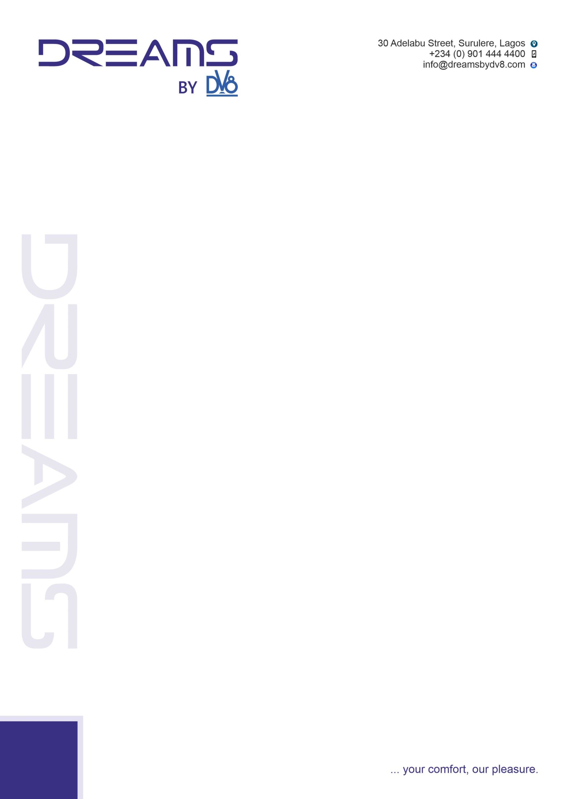

**STEPHEN OLADOKE**

Lagos

Nigeria

Dear Stephen,

**OFFER OF APPOINTMENT**

Sequel to your successful interviews with the management of Dreams by DV8 Hotel, we are pleased to advise that you have been offered employment with DREAMS BY DV8 HOTEL under the following terms and conditions:

**Position** : Software Engineer

**Remuneration** : 100,000 naira Gross monthly

**Resumption Date** : 1st june, 2022

**Working Days/Hours**: Remotely

**Probationary period**: You will be under probation for three months after which you will be made a full staff subject to a positive review. However, the hotel reserve the rights to terminate your contract if you do not perform to standard.

**Security deposit:** As part of our resignation policy**, two weeks’ salary will be withheld and deducted from your second month salary as a security deposit**. Employees are required to give the company a **minimum of two weeks’ notice for the junior staffs while senior staffs are expected to give a notice of one month.** If this is executed, the money withheld will be **refunded upon final exit settlement**, and if we do not receive any notice, the money will not be refunded.

If this is accepted by you, kindly acknowledge to this mail.

Yours Faithfully,

Human Resources Manager

Dreamsbydv8 Hotel